Dear colleagues,
Thank you very much for your participation at the Conference “”Business-Psychology: Theory and Practice.
At the end of the conference, the articles will be published in the Book of Proceeding, which will be indexed in the Web of Science.
Articles are accepted in English.
Deadline: 25 January 2019
After that, the articles will be reviewed by external reviewers, sent to the authors for revision (if recommended by reviewers) and the final decision on the publication.

Book of Proceedings (5-8 pages according to the guidelines)
The Proceedings of the 5th INTERNATIONAL CONFERENCE BUSINESS PSYCHOLOGY: THEORY AND PRACTICE 2018 will be sent for indexing in Thomson Reuters Web of Science Conference Proceedings Citation Index.
Authors are asked to adjust their papers to the following basic format:
I. Abstract
The abstract of the paper should be minimum 50 words, but not more than 250 words long. The summary should explain the purpose of the research, the methods and principal results, the major points of discussion and conclusions.
II. Keywords
III. Introduction
The introduction should start broad and narrow down to a specific thesis or research question. The introduction should reveal some broad knowledge of the overall topic and quickly focus on the major point of the paper.
IV. Background, History, Review-of-Literature, Methodology of the research
V. Results
This section catalogues the results of the research. The results should be presented in a clear and unbiased way.
VI. Discussion
This section is where the writer finally makes the major point or claim the previous sections have led the reader to expect.
VII. Conclusion
The conclusion should reinforce the major claims or interpretation in a way that is not mere summary. The writer should try to indicate the significance of the major claim/interpretation beyond the scope of the paper but within the parameters of the field. The writer might also suggest further research the study indicates is necessary.
VIII. References

Образец статьи:
TITLE OF THE PAPER
(Cambria 14 pt. in bold)
CENTERED
First name and surname (Cambria 10 pt. in bold)
Affiliated University
Faculty or other basic unit (Times New Roman 9 pt.)
Abstract: Abstract of the paper containing the aim of the research and information about its course and results. It should contain 500-1500 characters with spaces. The reader after reading the abstract should be familiar with the content of the paper. It is in the interest of the author to attract potential reader. The font of the abstract is Times New Roman 9 points, text centered, single spacing. Indentation on the left and right 0.75, intervals before 6 points, after 0 points
Key words: usually three to seven words, in alphabetical order, coma separated.
Introduction (Times New Roman 12 pt. in bold, interval before 24 pt, after 6 pt.)
In case of several authors from one university, enter them next to each other separated by a comma. In case of several authors from different universities, we use the division of the text into columns in the areas of "first name surname" and "affiliation". The paper is written in the Microsoft Word text editor, A4 format, margins: upper 2.5 cm, bottom 7 cm, left and right 4 cm. Text in Times New Roman font 11 points, single spacing between the lines, text justified, indentation of 0.5 cm. We do not divide words. In the text, we do not use bold distinctions and underlinings. It is allowed to mark foreign words in italics (e.g., caeteris paribus). We do not use spaces after the paragraph. We do not number subsequent parts of the text. Footnotes in the system similar to Harvard.
(Name year, page), eg.:
(Petrov 2010, p. 15)
(Petrov 2010a, p. 15)
(Petrov 2010b, p. 20)
(Petrov, Ivanov 2010, p. 15)
(Petrov, Ivanov, Sidorov 2010, p. 15)
(Petrov i in. 2010, p. 15) when the numer of authors exceeds three
(Petrov 1995, p. 10; Ivanov 2000, p. 10; Sidorov 2005, p. 25) chronologically
Main bullets (Times New Roman 12 pt. bolded, spacing before 16 pt, after 5 pt.)
If we use bullets, we use them according to the formula:
- bullets from hyphens, single spaces, hanging indent 0.63.
1. Indentation 0.63 for bullets or numbering.
Formulas in Times New Roman 10 points, spacing exactly 14 pt, centered, variables in italics or using the equation editor Microsoft Equation 3.0: Numbered equations.
(1)
Every equation should be described.
Second-order bullets (Times New Roman 11 pt. in bold, space before 12 pt, after 6 pt)
Tables are placed centered in the text. Table's signature placed in front of it. The font of tables content is Times New Roman 10 points or, if necessary, smaller, not limiting the readability of the table, the paragraph before and after 0 points, single spaces. In case of uneven text or value, we use vertical centering. We avoid bolding, we do not tone the interior. We do not leave empty cells.
Table 1. Table titles (above the table): Times New Roman 10 pt. in bold, italics, intervals before 6 pt, after the line 6 pt., justified, hanging indent 1,5
Description | Description |  | Description
Contents vertically centered horizontally to the left. | Content | - | Content vertically  and horizontally centered
content | Possible cells with a lack of data should be filled with the "-" or cut out as showed next to this cell.
Possible clarifications to the content (9 points) in the string with the source text, finished with shift + enter Source: (9 pts) intervals before 6 pts, 12 pts, we also use alignment to the left, if it is our own work.
Each drawing and table should be described in the text with an indication, e.g. (Table 1).
We sign the drawings below. Drawings should be pasted as a defined bitmap, which will allow to keep its form regardless of the program in which they will be opened by reviewers or proofreaders. Efforts should be made to make the content of the drawing legible, the axes described, the units applied. Drawings are printed in the gray scale, not in color. The author is responsible for correct descriptions and legibility of the drawing due to the colors used, textures or thickness of the line.
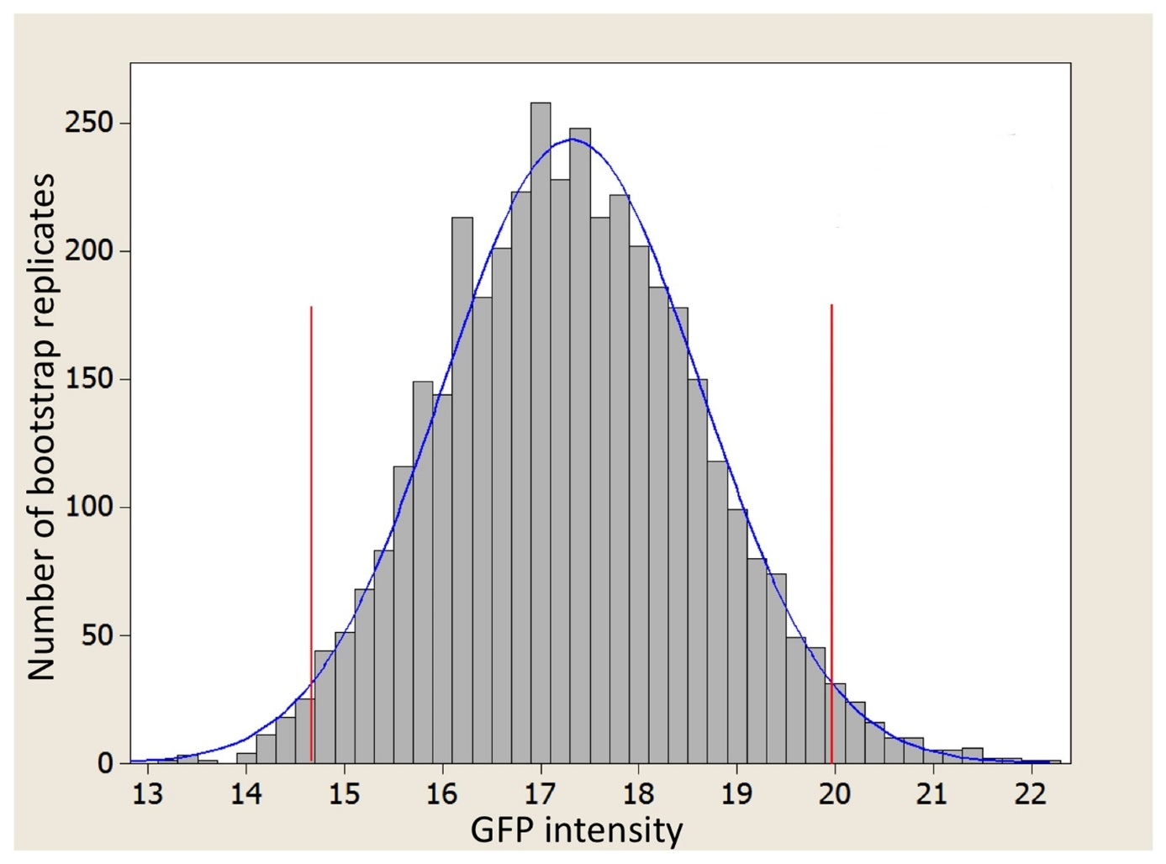
Figure 1. Figure titles (below figure): Times New Roman 10 pt. in bold, italics, spacing before and after the line 6 pt., justified, hanging indent 1,75
Possible clarifications to the content (9 points) in the string with the source text, finished shift + enter
Source: (9 pts) intervals before 3 pts, after 16 pts, we also give, if it is our own work, alignment to the left
Each figure should have a given source, be described and signaled in the text, e.g. (Figure 1). Tables and figures should not exceed the format of the magazine column, i.e. 13x20 cm, otherwise they must be divided between 2 pages.
Summary (Times New Roman 12 pt. in bold, space before 18 pt.,
after 6 pt.)
The text should not exceed 8 pages according to the formatting presented. Where possible, texts should contain an even number of pages. Below, in alphabetical order, we enclose literature items which have been indicated in the text or sources.

Literature (Times New Roman 12 pt. in bold, space before 18 pt.,
after 6 pt.)
Times New Roman font 9,5 pt.
Petrov A.I. (2010), Title of the publication, Publisher, Place of publication.
http://www.site.which.was used (access date: dd.mm.rrrr).
Ivanova P.N. (2010), Title of the chapter in publication, [in:] Nowak A. (ed.), Title of a multi-author publication , pp. from-to, Publisher, Place of publication.
Petrov A.I., Ivanov P.N.. (2010), Title of the publication, Publisher, Place of publication.
Petrov A.I., Ivanova P.N.. (ed.) (2010), Title of a multi-author publication, Publisher, Place of publication.
Petrov A.I. (2010), Title of the paper in the journal, „Title of the Journal”, number, volume, pp. from-to.
Petrov A.I. (2010), Title of the paper in electronic access, http://www.site.from.which.it.was.read/downloaded (access: dd.mm.rrrr).
The Act of 29 August 1997 Banking Law (Journal of Laws 1997 no 140 item 939).
Ivanov P.N. (2010), Title of the publication, Publisher, Place of publication.

Comments at the bottom of the page, font size 9, single spacing. Acknowledgments, indications on the use of funds or inspiration from people not included in the group of authors also in the comments.

